Erie 2024 Nearshore Rotifers
Chris Marshall
2026-10-20

Summer NS-OS Rotifer Genera Average Biomass Barplot
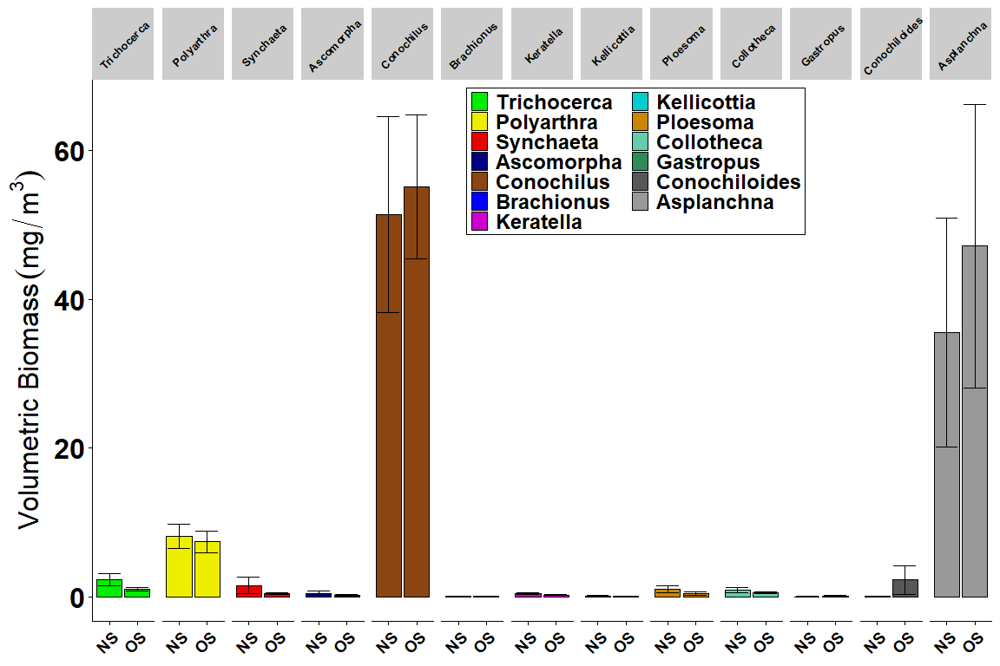
Figure 1A. Summer Rotifer genera nearshore (NS) vs. offshore (OS) average biomass (mg dry wt per m³). Error bars represent standard errors of the means. Taxa groups are identified in legend by color.
Figure 1A shows the volumetric biomass of the 13 most commonly encountered taxa between the nearshore and offshore samples for Lake Erie in August 2024. With several exceptions, most rotifer taxa exhibited higher average biomass values in the offshore samples, suggesting that these waters supported higher densities and perhaps larger taxa compared to shallower habitats. Several exceptions to this were Trichocerca, which had a higher biomass in the nearshore vs. offshore, and can be attributed to the higher nutrient concentrations found in nearshore waters supporting a greater density of these eutrophic-loving taxa (Gannon and Stemberger 1978; Sládecek, 1983). Synchaeta and Ploesoma showed a slight preference for the nearshore waters while Conochiloides showed a preference for the offshore waters. The remaining taxa Polyarthra, Ascomorpha, Brachionus, Keratella, etc, exhibited very similar biomass values between near- and offshore waters. These insights suggest that despite potentially higher food concentrations in nearshore habitats, only several taxa gain a clear advantage in these conditions.
Offshore Only: Finlinia Nearshore Only: Lepadella, Monostyla, Pompholyx, Trichotria
18 rotifer genera in the summer nearshore; 39 speccodes (species) Ascomorpha Asplanchna Brachionus Collotheca Conochiloides Conochilus Gastropus Kellicottia Keratella Lepadella Monostyla Ploesoma Polyarthra Pompholyx Rotifer Bdelloid Synchaeta Trichocerca Trichotria
15 rotifer genera in the summer offshore; 32 speccodes (species) Ascomorpha Asplanchna Brachionus Collotheca Conochiloides Conochilus Filinia Gastropus Kellicottia Keratella Ploesoma Polyarthra Rotifer Bdelloid Synchaeta Trichocerca
References:

Rotifer Genera Summer Nearshore-Offshore Density Barplot
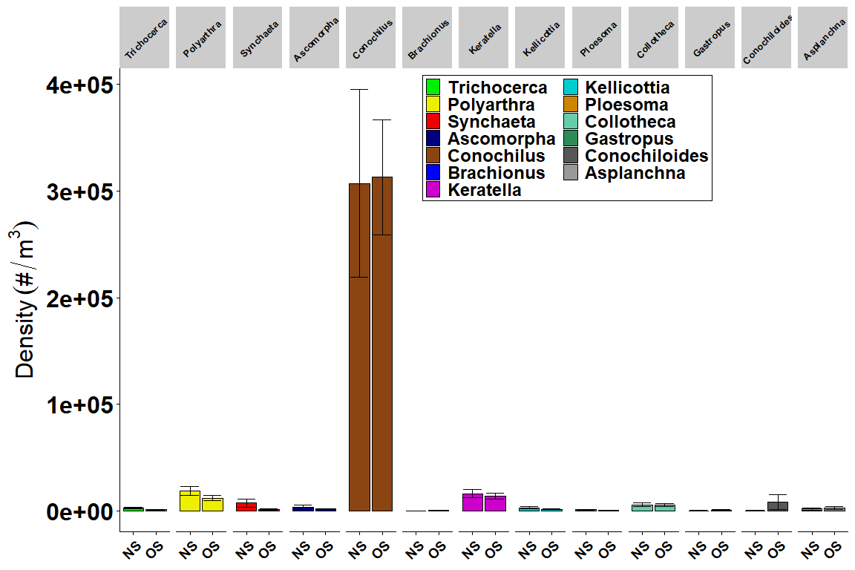
Figure 1B. Summer Rotifer genera nearshore (NS) vs. offshore (OS) average density (# per m³). Error bars represent standard errors of the means. Taxa groups are identified in legend by color.
Figure 1B shows the density of the 13 most commonly encountered taxa between the nearshore and offshore samples for Lake Erie in August 2024. With several exceptions, most rotifer taxa exhibited higher average density values in the nearshore samples, which is in contrast to average biomass values, indicating that smaller specimens or species are found in shallower habitats. Several taxa (Trichocerca, Polyarthra, Synchaeta, Ascomorpha) showed higher densities in the nearshore vs. offshore waters. Conochiloides was the only taxa that showed a clear preference for the offshore waters. The remaining taxa Brachionus, Keratella, Kellicottia, etc, exhibited very similar density values between near- and offshore waters. These insights suggest that despite potentially higher food concentrations in nearshore habitats, only several taxa gain an advantage in these conditions. Additionally, the contrasting findings that densities for several taxa are higher in the nearshore while biomass is similar or higher in the offshore, indicates there is a different rotifer community between the sample types.

Rotifer Genera Spring Nearshore-Offshore Biomass Barplot
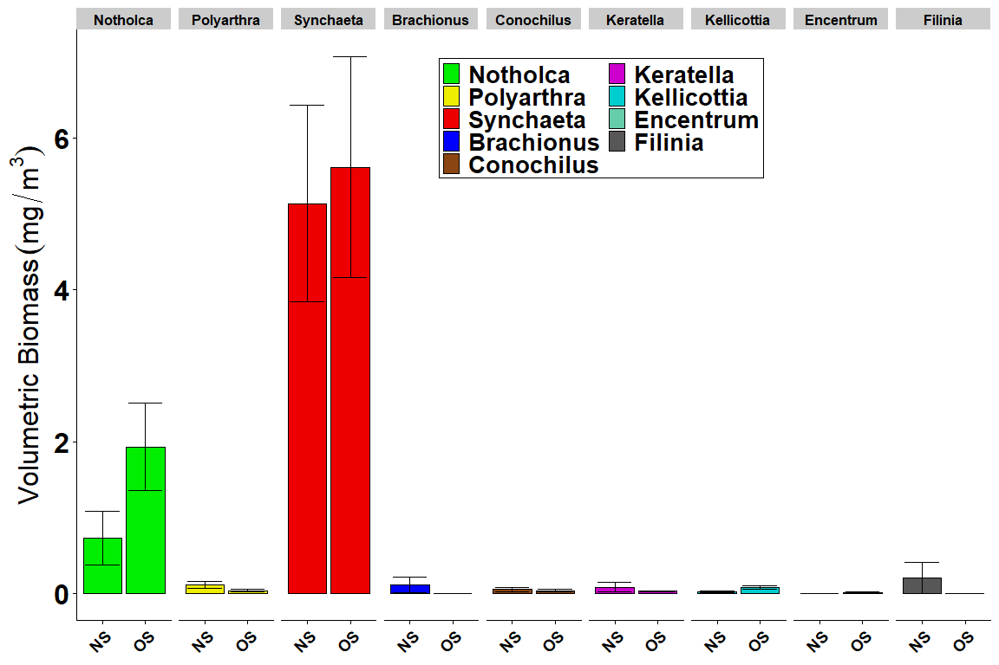
Figure 2A. Spring Rotifer genera nearshore (NS) vs. offshore (OS) average biomass (mg dry wt per m³). Error bars represent standard errors of the means. Taxa groups are identified in legend by color.
Figure 2A shows the biomass of the 9 most commonly encountered taxa between the nearshore and offshore samples for Lake Erie in April 2024. With several exceptions, most rotifer taxa exhibited higher average biomass values in the offshore samples. Several taxa (Polyarthra, Brachionus, Filinia) showed higher densities in the nearshore vs. offshore waters. Notholca was the only taxa that showed a clear preference for the offshore waters. The remaining taxa Synchaeta, Conochilus, Keratella, Kellicottia, Encentrum, exhibited very similar biomass values between near- and offshore waters. These insights suggest that despite potentially higher food concentrations in nearshore habitats, only several taxa gain an advantage in these conditions.
Nearshore Only: Asplanchna, Mytilina, Ploesoma, Trichocera, Trichotria Offshore Only: Colurella, Gastropus, Monostyla, Pompholyx, Rotifer Bdelloid
18 rotifer genera found in NS spring; 32 speccodes (species) Asplanchna Brachionus Cephalodella Conochilus Encentrum Euchlanis Filinia Kellicottia Keratella Mytilina Notholca Notomatta Ploesoma Polyarthra Proales Synchaeta Trichocerca Trichotria
18 rotifer genera found in the OS spring; 35 speccodes (species) Brachionus Cephalodella Colurella Conochilus Encentrum Euchlanis Filinia Gastropus Kellicottia Keratella Monostyla Notholca Notomatta Polyarthra Pompholyx Proales Rotifer Bdelloid Synchaeta

Rotifer Genera Spring Nearshore-Offshore Density Barplot
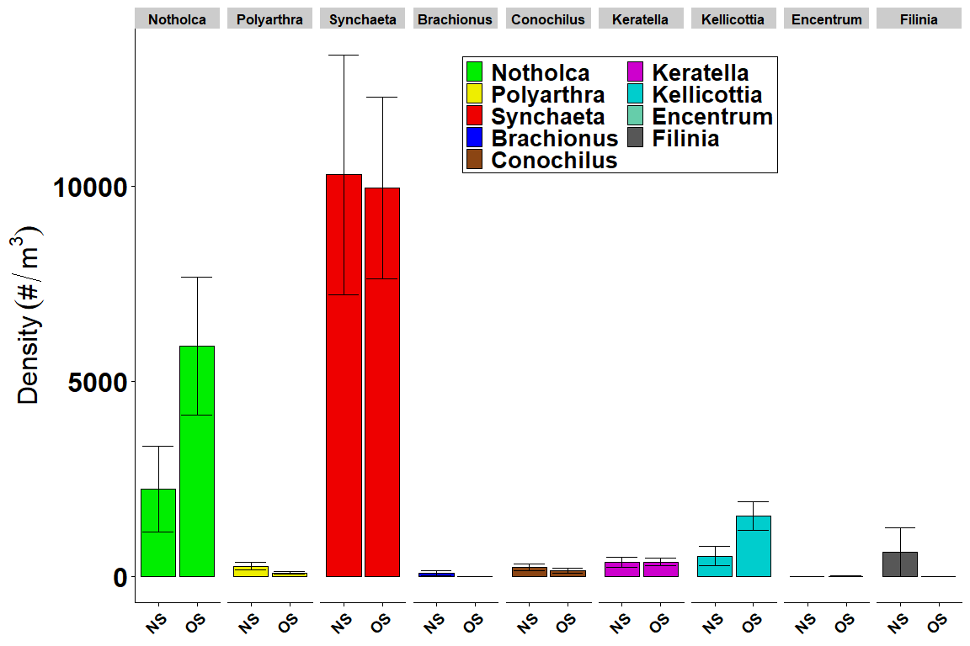
Figure 2B. Spring Rotifer genera nearshore (NS) vs. offshore (OS) average density (# per m³). Error bars represent standard errors of the means. Taxa groups are identified in legend by color.
Figure 2B shows the density of the 9 most commonly encountered taxa between the nearshore and offshore samples for Lake Erie in April 2024. With several exceptions, most rotifer taxa exhibited higher average density values in the nearshore samples. Several taxa (Polyarthra, Brachionus, Filinia) showed higher densities in the nearshore vs. offshore waters. Notholca and Kellicottia both showed a clear preference for the offshore waters. The remaining taxa Synchaeta, Conochilus, Keratella, Encentrum, exhibited very similar density values between near- and offshore waters. These insights suggest that despite potentially higher food concentrations in nearshore habitats, only several taxa gain an advantage in these conditions.

Rotifer Genera Summer Nearshore-Offshore Biomass Boxplot
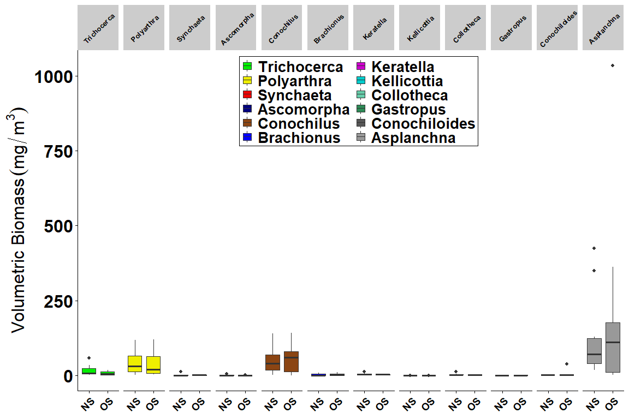
Figure 3A. Summer Rotifer genera nearshore (NS) vs. offshore (OS) average biomass (mg dry wt per m³) boxplots. Taxa groups are identified in legend by color.
Table 1. Rotifer Biomass Summer LME Tukey Pairwise Comparisons
contrast | Rot_GENERA | estimate | SE | df | t.ratio | p.value
NS - OS | Ascomorpha | -45.733333 | 32.2407 | 596.5741 | -1.4184967 | 0.1565680
NS - OS | Asplanchna | -18.766667 | 32.2407 | 596.5741 | -0.5820799 | 0.5607327
NS - OS | Brachionus | -4.033333 | 32.2407 | 596.5741 | -0.1251007 | 0.9004860
NS - OS | Collotheca | 14.966667 | 32.2407 | 596.5741 | 0.4642165 | 0.6426620
NS - OS | Conochiloides | -63.550000 | 32.2407 | 596.5741 | -1.9711108 | 0.0491730
NS - OS | Conochilus | 13.900000 | 32.2407 | 596.5741 | 0.4311320 | 0.6665281
NS - OS | Euchlanis | 0.000000 | 32.2407 | 596.5741 | 0.0000000 | 1.0000000
NS - OS | Filinia | -8.950000 | 32.2407 | 596.5741 | -0.2775994 | 0.7814161
NS - OS | Gastropus | -23.500000 | 32.2407 | 596.5741 | -0.7288923 | 0.4663536
NS - OS | Kellicottia | 0.000000 | 32.2407 | 596.5741 | 0.0000000 | 1.0000000
NS - OS | Keratella | 32.300000 | 32.2407 | 596.5741 | 1.0018392 | 0.3168275
NS - OS | Lepadella | 20.083333 | 32.2407 | 596.5741 | 0.6229186 | 0.5335761
NS - OS | Mytilina | 0.000000 | 32.2407 | 596.5741 | 0.0000000 | 1.0000000
NS - OS | Ploesoma | 39.866667 | 32.2407 | 596.5741 | 1.2365321 | 0.2167474
NS - OS | Polyarthra | 2.733333 | 32.2407 | 596.5741 | 0.0847790 | 0.9324656
NS - OS | Pompholyx | 18.833333 | 32.2407 | 596.5741 | 0.5841477 | 0.5593418
NS - OS | Proales | 0.000000 | 32.2407 | 596.5741 | 0.0000000 | 1.0000000
NS - OS | Synchaeta | 46.200000 | 32.2407 | 596.5741 | 1.4329712 | 0.1523899
NS - OS | Trichocerca | 16.333333 | 32.2407 | 596.5741 | 0.5066060 | 0.6126185
NS - OS | Trichotria | 18.250000 | 32.2407 | 596.5741 | 0.5660546 | 0.5715695

Rotifer Genera Spring Nearshore-Offshore Biomass Boxplot
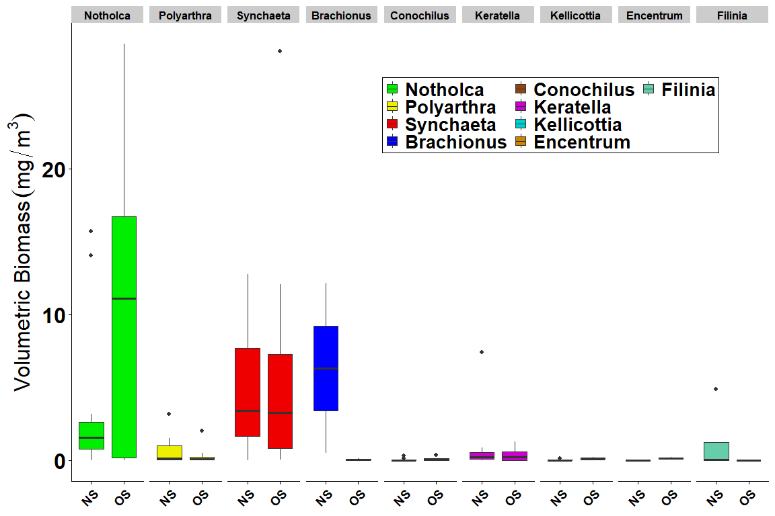
Figure 3B. Spring Rotifer genera nearshore (NS) vs. offshore (OS) average biomass (mg dry wt per m³) boxplots. Taxa groups are identified in legend by color.
Table 2. Rotifer Biomass Spring LME Tukey Pairwise Comparisons
contrast | Rot_GENERA | estimate | SE | df | t.ratio | p.value
NS - OS | Brachionus | 37.3666667 | 33.05585 | 677.1882 | 1.1304100 | 0.2587037
NS - OS | Cephalodella | 57.2666667 | 33.05585 | 677.1882 | 1.7324213 | 0.0836539
NS - OS | Collotheca | 0.0000000 | 33.05585 | 677.1882 | 0.0000000 | 1.0000000
NS - OS | Colurella | -17.2250000 | 33.05585 | 677.1882 | -0.5210877 | 0.6024760
NS - OS | Conochiloides | 0.0000000 | 33.05585 | 677.1882 | 0.0000000 | 1.0000000
NS - OS | Conochilus | 147.0166667 | 33.05585 | 677.1882 | 4.4475228 | 0.0000102
NS - OS | Encentrum | 12.4666667 | 33.05585 | 677.1882 | 0.3771394 | 0.7061881
NS - OS | Euchlanis | -7.2750000 | 33.05585 | 677.1882 | -0.2200820 | 0.8258736
NS - OS | Filinia | 103.6583333 | 33.05585 | 677.1882 | 3.1358540 | 0.0017877
NS - OS | Kellicottia | 5.9500000 | 33.05585 | 677.1882 | 0.1799984 | 0.8572077
NS - OS | Keratella | 27.1083333 | 33.05585 | 677.1882 | 0.8200766 | 0.4124610
NS - OS | Lepadella | 0.0000000 | 33.05585 | 677.1882 | 0.0000000 | 1.0000000
NS - OS | Monostyla | -14.0250000 | 33.05585 | 677.1882 | -0.4242819 | 0.6714950
NS - OS | Mytilina | 22.9583333 | 33.05585 | 677.1882 | 0.6945315 | 0.4875871
NS - OS | Notholca | 21.3750000 | 33.05585 | 677.1882 | 0.6466328 | 0.5180887
NS - OS | Notomatta | -4.7250000 | 33.05585 | 677.1882 | -0.1429399 | 0.8863802
NS - OS | Polyarthra | 24.8000000 | 33.05585 | 677.1882 | 0.7502453 | 0.4533675
NS - OS | Pompholyx | -13.6750000 | 33.05585 | 677.1882 | -0.4136937 | 0.6792294
NS - OS | Proales | 35.9083333 | 33.05585 | 677.1882 | 1.0862927 | 0.2777360
NS - OS | Rotifer Bdelloid | -33.8000000 | 33.05585 | 677.1882 | -1.0225118 | 0.3069039
NS - OS | Synchaeta | 0.0333333 | 33.05585 | 677.1882 | 0.0010084 | 0.9991957
NS - OS | Trichocerca | 24.2083333 | 33.05585 | 677.1882 | 0.7323463 | 0.4642106
NS - OS | Trichotria | 22.8750000 | 33.05585 | 677.1882 | 0.6920106 | 0.4891679

Lake Erie 2024 Study Area Station Map
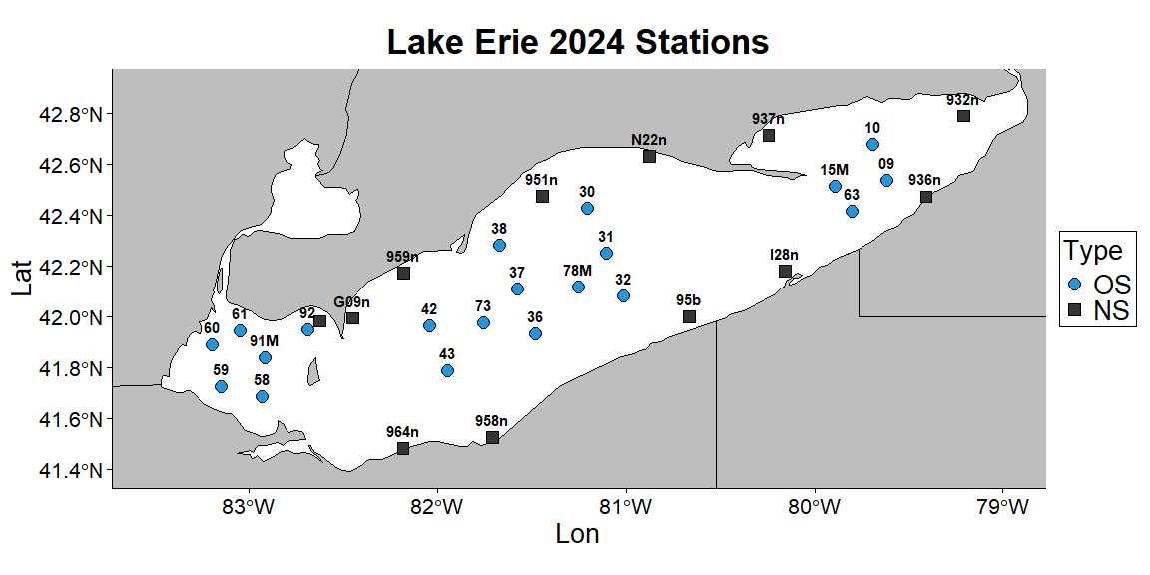
Figure 4. Rotifer study area for 2024 samples collected at the 20 offshore sites (OS - blue filled circles), and the 12 CSMI nearshore sites (NS - black filled boxes).

Rotifer Summer Genera Station Total Biomass Barplot
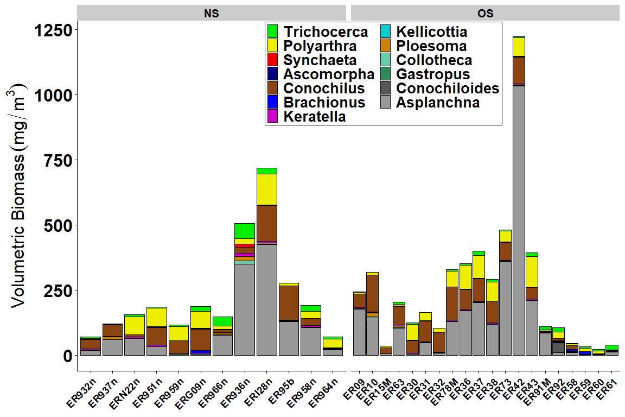
Figure 5A. Summer Rotifer genera station total biomass (mg dry wt per m³) for the the 12 CSMI nearshore sites ordered from east to west (7 northshore, 5 south), and the 20 offshore sites ordered from east to west (4 east basin, 10 central, 6 west).
Figure 5A represents the individual station total rotifer biomass for the 13 most common taxa collected during the Lake Erie August 2024 survey. The stations are separated by the nearshore (NS) and offshore (OS) samples ordered from east to west. The first 7 listed nearshore samples were collected from the northshore of Lake Erie and show a lower overall biomass compared with the 5 subsequent stations collected from the southshore of the lake. That biomass disparity is largely driven by higher Asplanchna values in several southshore samples. Station ER936n shows a particularly diverse community compared with other stations, and is close in proximity to Van Buren Bay close to Dunkirk, NY. The offshore samples are separated by their basins (4 east, 10 central, 6 west), which are distinct due to the large change in bathymetric depths between basins, resulting in very different ecological implications for the zooplankton communities. The eastern basin is the deepest and most similar to the Lake Ontario rotifer community, and with the exception of ER15M which is missing the large Asplanchna biomass, those 4 samples are similar. The first 3 central samples are similar with relatively low overall biomass with the addition of more Polyarthra. With the exception of ER42 which shows a massive Asplancha biomass, the remaining central stations exhibit a similar community, with more Polyarthra and Trichocera biomass moving westward. The western basin is historically the most diverse community in the Great Lakes, with very shallow and eutrophic waters that support a unique assemblage of rotifers. A higher proportion of Trichocera, Polyarthra, and Brachionus is indication of greater nutrient availability, and therefore a more diverse set of food resources compared with other localities. It should be noted that the despite these resources, the western basin often exhibits the lowest biomass and density of rotifers, which is impacted by the shallow waters (~6 meters), discharge from the Detroit River and Maumee River, and higher potential of predation by larger zooplankton and larval fish.

Rotifer Summer Genera Station Total Density Barplot
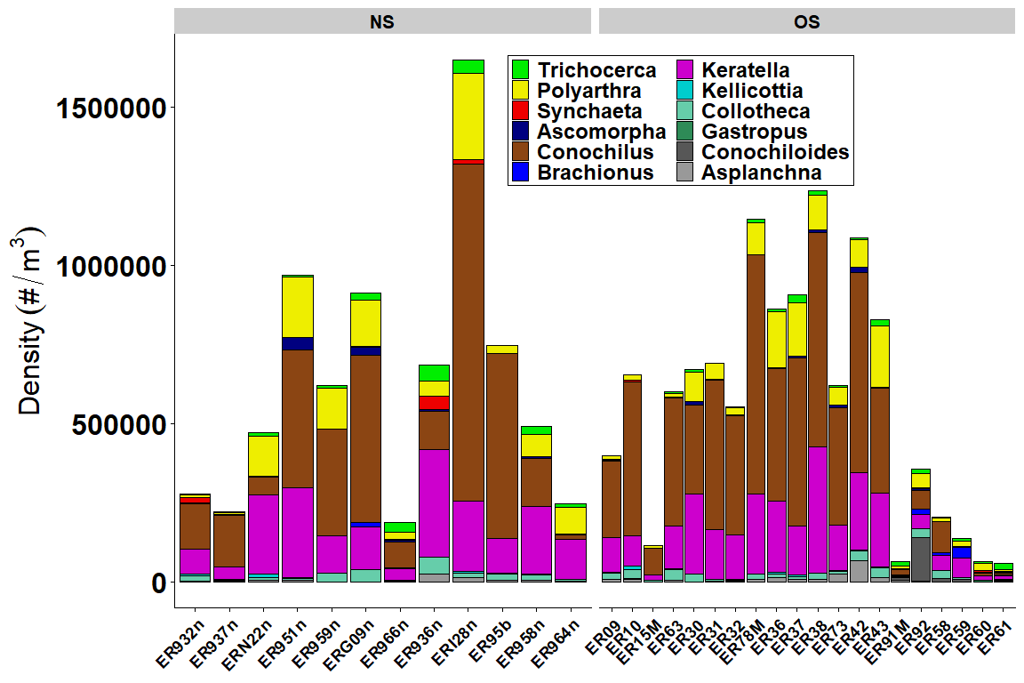
Figure 5B. Summer Rotifer genera station total density (# per m³) for the 12 CSMI nearshore sites ordered from east to west (7 northshore, 5 south), and the 20 offshore sites ordered from east to west (4 east basin, 10 central, 6 west).
Figure 5B represents the individual station total rotifer density for the 13 most common taxa collected during the Lake Erie August 2024 survey. The stations are separated by the nearshore (NS) and offshore (OS) samples ordered from east to west. The first 7 listed nearshore samples were collected from the northshore of Lake Erie and show a similar overall density compared with the 5 subsequent stations collected from the southshore of the lake. That density similarity is driven by several taxa including the colonial Conochilus, Keratella, and Polyarthra. Pick up notes for figure 5B here

Rotifer Spring Genera Station Total Biomass Barplot
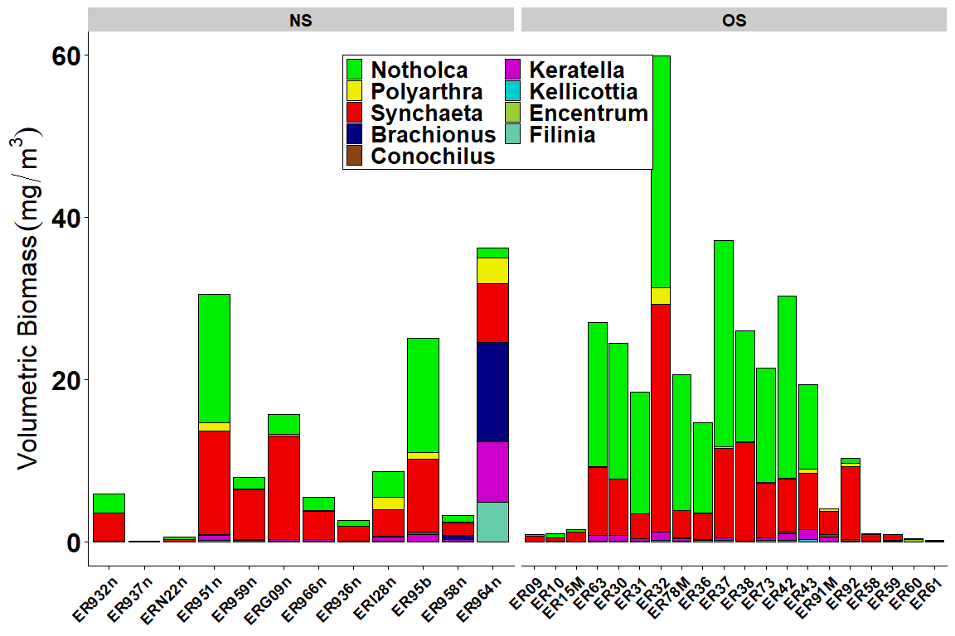
Figure 6A. Spring Rotifer genera station total biomass (mg dry wt per m³) for the 12 CSMI nearshore sites ordered from east to west (7 northshore, 5 south), and the 20 offshore sites ordered from east to west (4 east basin, 10 central, 6 west).

Rotifer Spring Genera Station Total Density Barplot
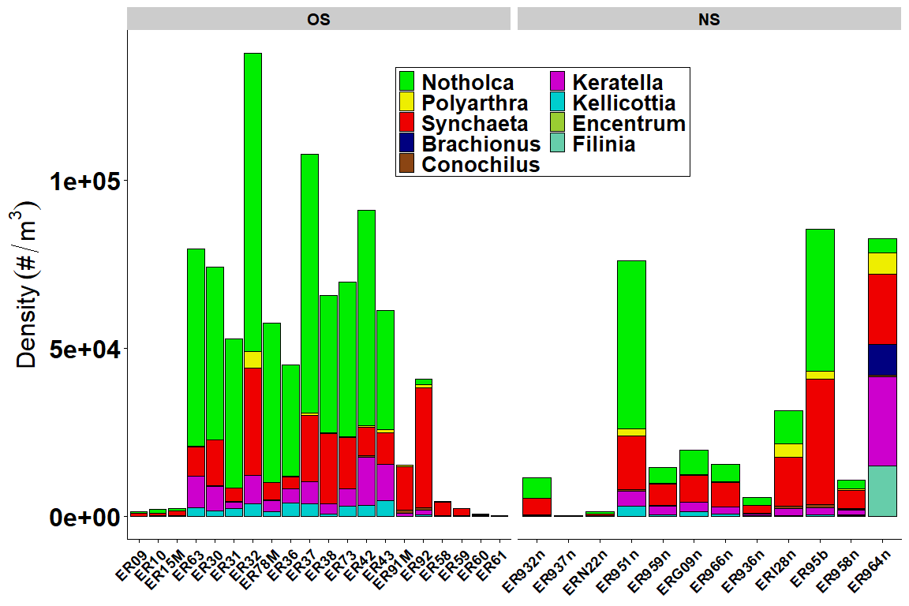
Figure 6B. Spring Rotifer genera station total density (# per m³) for the 12 CSMI nearshore sites ordered from east to west (7 northshore, 5 south), and the 20 offshore sites ordered from east to west (4 east basin, 10 central, 6 west).

Zoop Taxa Summer Nearshore-Offshore Biomass Barplot
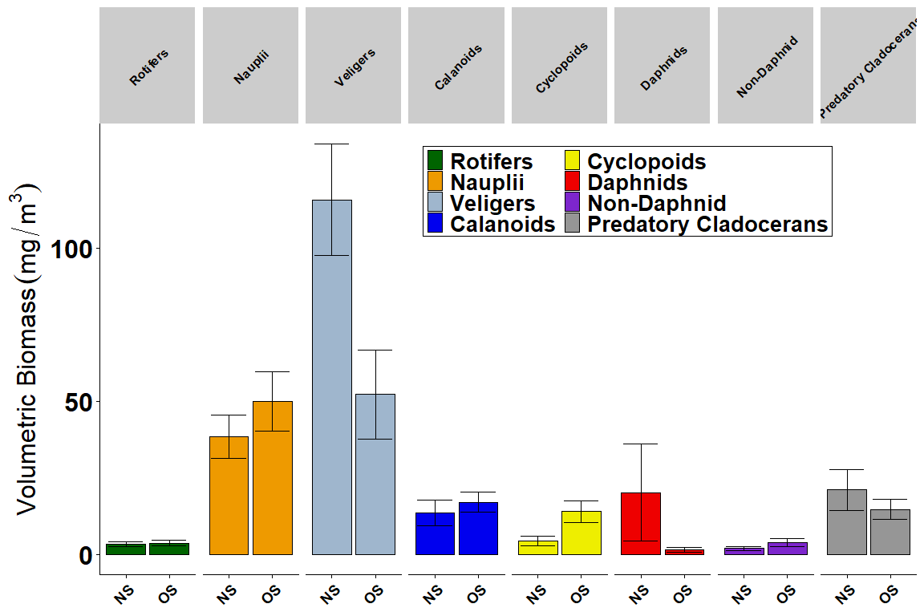
Figure 7A. Summer Zoop taxa nearshore (NS) vs. offshore (OS) average biomass (mg dry wt per m³). Error bars represent standard errors of the means. Taxa groups are identified in legend by color.

Zoop Taxa Spring Nearshore-Offshore Biomass Barplot
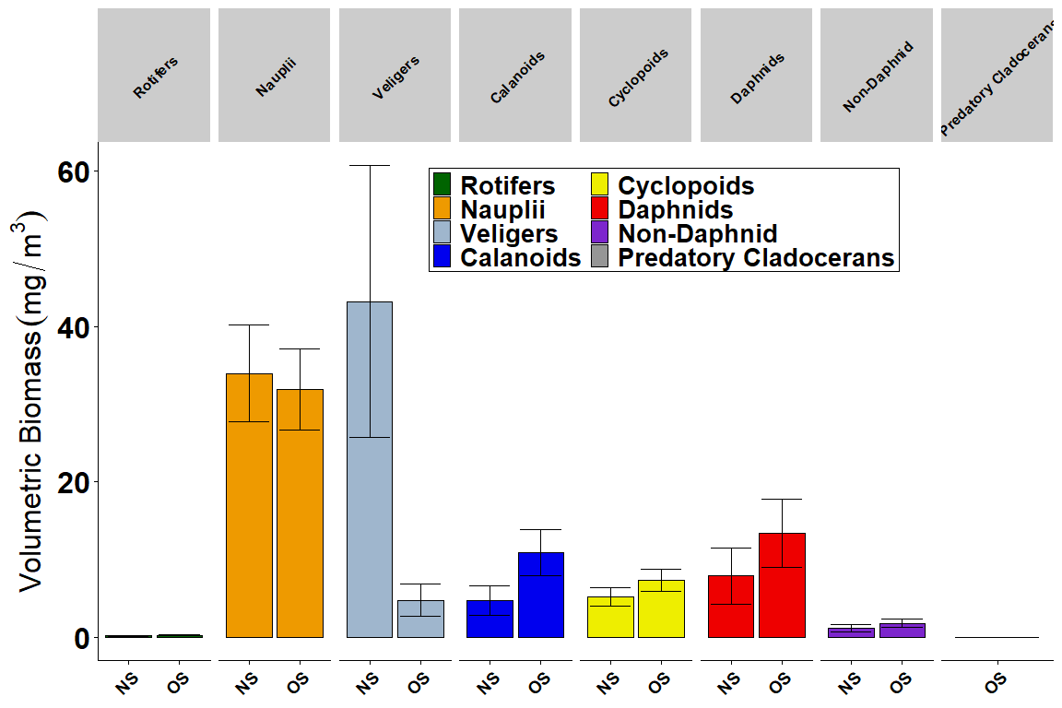
Figure 7B. Spring Zoop taxa nearshore (NS) vs. offshore (OS) average biomass (mg dry wt per m³). Error bars represent standard errors of the means. Taxa groups are identified in legend by color.

Zoop Summer Taxa Station Total Biomass Barplot
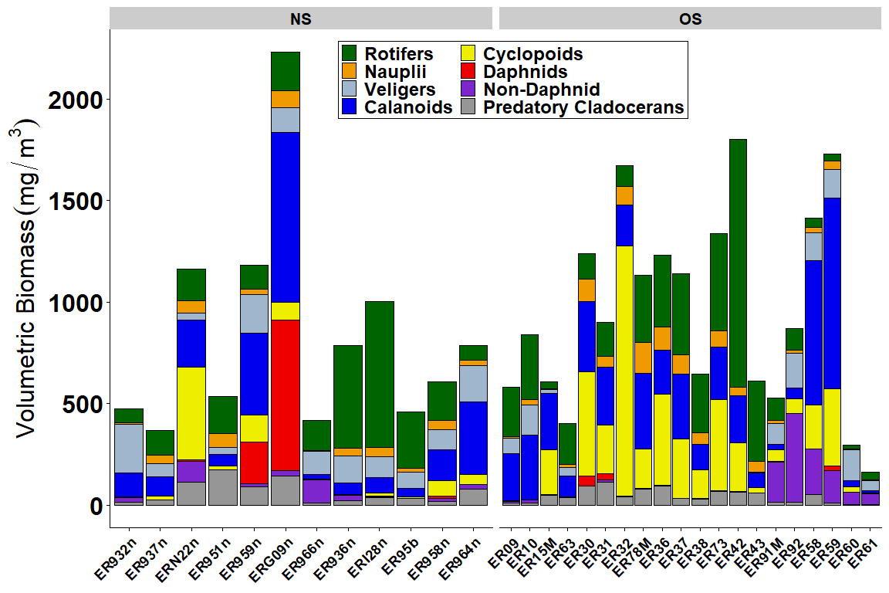
Figure 8A. Summer Zoop taxa station total biomass (mg dry wt per m³) for the 12 CSMI nearshore sites ordered from east to west (7 northshore, 5 south), and the 20 offshore sites ordered from east to west (4 east basin, 10 central, 6 west).

Zoop Spring Taxa Station Total Biomass Barplot
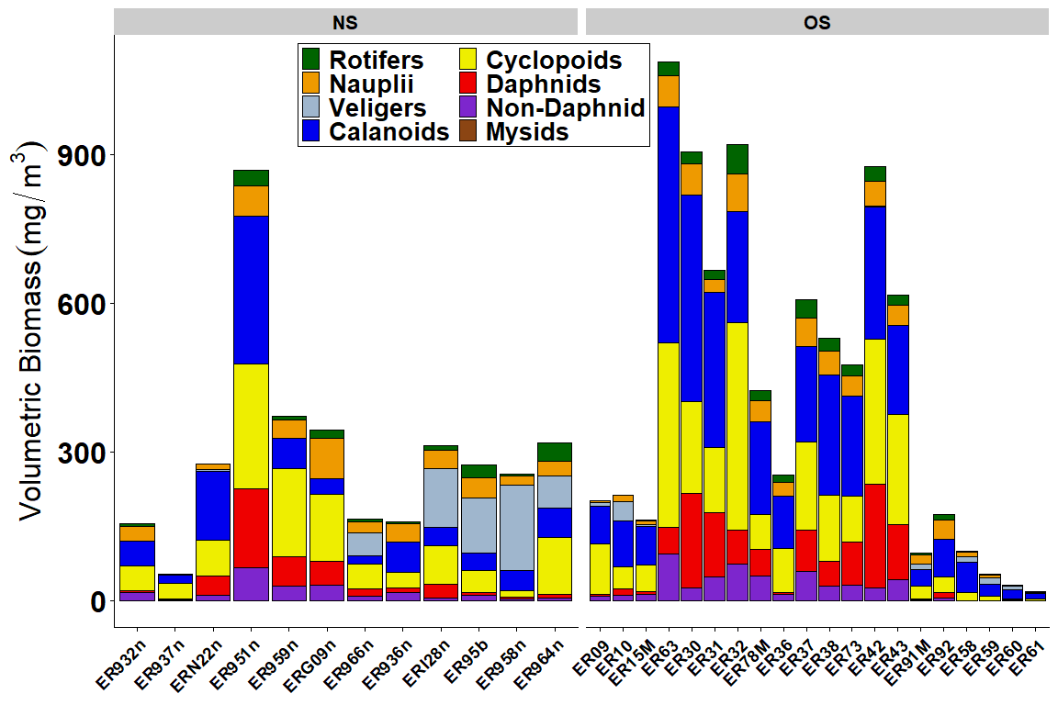
Figure 8B. Spring Zoop taxa station total biomass (mg dry wt per m³) for the 12 CSMI nearshore sites ordered from east to west (7 northshore, 5 south), and the 20 offshore sites ordered from east to west (4 east basin, 10 central, 6 west).

